In the context of IoT (Internet of Things), the APS (Application Support Sublayer) layer is a crucial component of the IEEE 802.15.4 standard, which defines the physical (PHY) and medium access control (MAC) layers for low-power, low-data-rate wireless communication networks. The APS layer, sometimes referred to as the Network Layer, is responsible for providing key functionalities to enable application-specific communication and data management within IoT networks. Here's an extensive discussion of the APS layer in IoT:

**Functions of the APS Layer:**

* **Device Addressing:** One of the primary functions of the APS layer is device addressing. It assigns unique addresses to individual devices within the IoT network. These addresses are essential for identifying devices and facilitating communication between them.
* **Endpoint Identification:** The APS layer uses endpoints to categorize the functionalities or services provided by IoT devices. Each device can have multiple endpoints, each associated with a specific service or application. Endpoints enable devices to offer a range of services simultaneously.
* **Message Framing:** The APS layer is responsible for creating message frames that encapsulate application data. It adds necessary headers and footers to application messages to ensure proper routing and delivery. These frames contain information such as source and destination addresses, endpoints, and payload length.
* **Message Routing:** Routing decisions are made at the APS layer. It determines how messages should be forwarded from the source device to the destination device. The APS layer is responsible for selecting the appropriate route within the network.
* **Security:** The APS layer plays a crucial role in ensuring the security of data transmitted within IoT networks. It manages security services such as encryption, decryption, authentication, and key management to protect data from unauthorized access and tampering.
* **Group Communication:** APS supports group communication by allowing devices to belong to multiple groups. This feature is valuable for scenarios where multiple devices need to receive the same message simultaneously, such as controlling a group of lights in a smart home.
* **Binding and Discovery:** The APS layer facilitates service discovery and device binding. Devices can discover the available services on other devices and establish logical links for communication.

**Protocols and Standards:**

The APS layer operates in conjunction with other layers in the IoT protocol stack, such as the Network Layer and Transport Layer. It often works with the Zigbee application framework, which is built on top of IEEE 802.15.4 and provides a standardized way to develop IoT applications.

The Zigbee Alliance defines various application profiles and clusters that specify how devices should communicate in different application domains, such as home automation, healthcare, and industrial control. These profiles and clusters define standardized services and attributes that enable interoperability between devices from different manufacturers.

The APS provides services to the application layer and the network layer through the application support data entity (APSDE) and application support management entity (APSME).

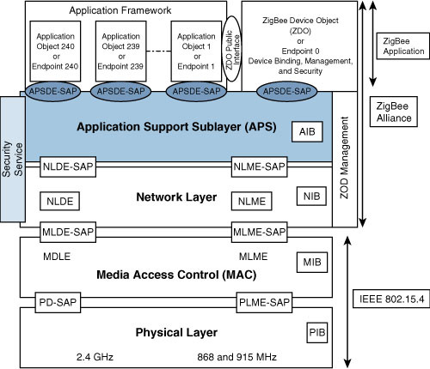

**Challenges and Considerations:**

* **Interoperability:** Ensuring interoperability between devices from different manufacturers is a significant challenge in IoT networks. Standardization efforts and adherence to application profiles help address this challenge.
* **Security:** Securing IoT communication is critical, and the APS layer plays a vital role in implementing security mechanisms. Protecting against various security threats, including eavesdropping and device spoofing, is essential.
* **Scalability:** IoT networks can grow significantly in terms of the number of devices and endpoints. Designing networks that can scale efficiently while maintaining performance is a consideration in APS layer design.
* **Energy Efficiency:** Many IoT devices are battery-operated and have limited power resources. Optimizing the energy efficiency of communication protocols and minimizing unnecessary overhead is crucial.

In conclusion, the APS layer in IoT networks is responsible for device addressing, message framing, routing, security, and other critical functions that enable application-specific communication. It plays a central role in ensuring efficient and secure data transmission within IoT networks and is a key component in achieving the goals of the Internet of Things.

**Questions:**

**Knowledge Level (Remember/Recall):**

1. Question: What does APS stand for in the context of IoT networks?
2. Question: What is the primary function of the IoT APS layer?

**Comprehension Level (Understand):**

1. Question: How does the APS layer contribute to device addressing in IoT networks?
2. Question: What is the purpose of endpoint identification in the APS layer?

**Application Level (Apply):**

1. Question: Can you provide an example of a situation where message framing in the APS layer is necessary?
2. Question: How does the APS layer enable group communication in IoT networks?

**Analysis Level (Analyze):**

1. Question: Explain the role of the APS layer in ensuring the security of data transmitted within IoT networks.
2. Question: What are the challenges associated with achieving interoperability in IoT networks, and how does the APS layer address them?

**Synthesis Level (Create):**

1. Question: Design a simple IoT application scenario and outline how the APS layer would be involved in data transmission.

**Evaluation Level (Evaluate):**

1. Question: Assess the importance of energy efficiency in the APS layer for battery-operated IoT devices.